**PROJECT REPORT**

***on***

IMPLEMENTATION OF CHILD RESCUE SYSTEM FROM BOREWELLS USING ZIGBEE FOR LONG RANGE APPLICATIONS

**18ECP109L – Major Project**

***Submitted by***

Yarabolu Sisindhar Reddy(RA1811004010644)

**Semester – VIII**

**Academic Year: 2021-22**

***Under the supervision of***

Dr.R.Manohari

Associate Professor, Department of ECE



**DEPARTMENT OF ELECTRONICS AND COMMUNICATION ENGINEERING**

**College of Engineering and Technology,**

**SRM Institute of Science and Technology**

SRM Nagar, Kattankulathur – 603203, Chengalpattu District, Tamil nadu.

**May 2022**

**SRM INSTITUTE OF SCIENCE AND TECHNOLOGY**

(Under Section 3 of UGC Act, 1956)

**BONAFIDE CERTIFICATE**

Certified that this report titled **“c”** is the Bonafide work of **“YARABOLU SISINDHAR REDDY (RA1811004010644)** who carried  out the Major Project. Certified further, that to the best of my knowledge the work reported does not form  any other project report or dissertation on the basis of which a degree or award was conferred on an earlier  occasion on this or any other candidate.





**DECLARATION**

I hereby declare that the Major Project entitled “IMPLEMENTATION OF CHILD RESCUE SYSTEM FOR BOREWELLS USING ZIGBEE FOR LONG RANGE APPLICATIONS” to be submitted for the Degree of  Bachelor of Technology is our original work as a team and the dissertation has not formed the basis of any degree, diploma, associate ship or fellowship of similar other titles. It has not been submitted to  any other University or institution for the award of any degree or  diploma.

Place : SRMIST

Date : 06-05-2022

Yarabolu Sisindhar reddy(RA1811004010644)

**ACKNOWLEDGEMENTS**

I would like to extend our heartfelt gratitude to my Chancellor Shri.T.R.Pachamuthu, Vice-Chancellor Dr. C. Muthamizhchelvan, Pro-Chancellor Dr. P. Sathyanarayanan for providing me with the necessary facilities for the completion of this project. we also acknowledge our Registrar Dr. S. Ponnusamy for his constant support and endorsement. we wish to express my sincere gratitude to Prof. T.V.Gopal Dean, (Engineering & Technology), and Dr. Shanthi prince, Professor& Chairperson (Department of Electronics and Communication Engineering) for their constant support and encouragement. we are extremely grateful to my Project Co-ordinator Dr.C.T.Maninegalai, Assistant Professor (Department of Electronics and Communication Engineering) for her invaluable guidance, motivation, timely and insightful technical discussions. we are immensely grateful for her constant encouragement, smooth approach throughout my project period and made this work possible. we are deeply indebted to my Project Guide Dr. R.Manohari, Associate Professor (Department of Electronics and Communication Engineering) and other faculties of the Department of Electronics and Communication Engineering for extending their warm support, constant encouragement, and ideas they shared with us. we would be failing my part if we do not acknowledge our family members and also our friends for their constant encouragement and support.

**ABSTRACT**

In recent years,many cases have been reported of children getting trapped in borwells which take life of the children and are a night mare for parents.there is a definite need of developing a security and rescue system for children to rescue from borewell.The current rescue system are time taking,and are not at all accurate as involve manual help where there are many chances of human error.the bore well cases have taken many lives of innocent children while playing in that area the process is very complicated and may be if some one is stuck a notification is also not received.A new child rescue system is proposed in which use of sensors and microcontrollers for rescue improves the efficiency of the system.the child can be rescued with hand gripper with utmost safety.thid helps in rescue of borewells and gives the real time data of sensors and LCD module of the system through communication

**TABLE OF CONTENTS**

| **TITLE** | **PAGE NO** |
| --- | --- |
| **ABSTRACT** | 5 |
| **TABLE OF CONTENTS** | 6 |
| **LIST OF TABLES** | 7 |
| **LIST OF FIGURES** | 8 |
| **1. INTRODUCTION** | 9 |
| **2. LITERATURE** | 10 |
| 3.RESEARCH METHODOLOGY3.1. Statement of the problem3.2. Objective3.3. Methodology3.4. Hardware Specification3.5. Software Specification3.6. Work plan3.7. Realistic Constraints3.8. Multidisciplinary Task involved | 11  11  12  12  16  16  16  17 |
| **4.WORKING**  4.1. Proposed Design  4.2. Prototype  4.3. Result  4.4. Applications  4.5. Budget | 18  19  2  21  21 |
| **5. CONCLUSION** | 22 |
| **6. FUTURE WORK** | 23 |
| **7. REFERENCES** | 24 |

# LIST OF TABLES

1. Literature

2. Multidisciplinary Tasks Involved

3. Budget

**LIST OF FIGURES**

1. Methodology

2. Microcontroller

3. 4 Channel 5v relay module

4. temperature sensor

5. pir sensor

6. gas sensor

7. pressure sensor

8.2 relay module

9. Proposed Design

10. Prototype

**CHAPTER 1**

**INTRODUCTION**

India is an agricultural based country, ranchers or farmers basically rely generally upon ground water for their basic water frame work requirements. Now for the growing populace, lesser land based assets and the advancement of urbanization of the very progressively significant requirement of the borewells are usually tunneled for the groundwater pondering requirement.subsequent to the basic requirement yielding of the water.The borewells would have generally left revealed.So,that most far by kids coincidentally moves towards the well and fall into it,which is the main purposr for these disasters.the rescue activities as a rule are less secure even to the rescue colleagues.at present there is no legitimate strategy for managing this issue. At the point where the bore wells are burrowed, it isn’t appropriately shut.the Little kids accidently fall into borewells.Most by far of the youngsters accidentally moves towards the wells and fall into it.In the wake of teaching everyone respect to their borewell mishaps,there showed up on be no advancement in the quantity of weepy accidents.A coustomary self- ruling robot can easily play out the first and third operations in less time.To overcome these obstacles ,we have outlined a drag well rescue robot with propelled gear and gadgets

**CHAPTER 2**

**LITERATURE SURVEY**

**2.1 Development of in-pipe Robot for assisting borewell operations**

**Authors**: **Aashvji shenai, Abhijeet Antin, R.pallavai, Dawnee soman**.

In this we can say that Robotics is the areas which can br explored to achieve this objective.this work illustrates an innovative methods to access the condition of the victim by analysing various details like the depth at which the child is stuck , detection of harmless gases present, temperature , humidity conditions and live feed of the victim using an

in pipe robot.

**2.2 Arduino Based smart Borewell ambulance Rescue system**

**Author: Tanveer sultana, Basavarja patil**

In this the need of the project is auduino with software for sensors and identify the which wss fell in the borewells for this we are need of microcontroller and we IRI sensor for Arduino uno controller

**2.3 Implementation of child rescue system from borewell using zigbee for long range applications**

**Authors: Siddharth Singh, Manash Baruah, Rahul kumar verma**

In this we taken sensors and micro controllers for rescue improves the efficiency of the system. Real time data sensors and LCD of the system through communication with zigbee.

**CHAPTER 3**

**METHODOLOGY**

**3.1 Statement of the problem**

* To rescue baby from borewells.
* Zigbee and wireless technology is used.

**3.2 Objective**

* Manually monitoring system the child with the help of camera and controlling unit of system.
* Communicating with the system by sending appropriate commands to it and activate suitable motors.
* Once the system has reached proximity of child it stops immediately and given commands by the controlling device to perform the closing of the systemic arms.
* Controlling a system to take off the child inside the borewell, which is controlled by the person from outside

**3.3 Methodology**

































Fig 1: Methodology

**3.4 Hardware Specifications:**

**Micro controller**

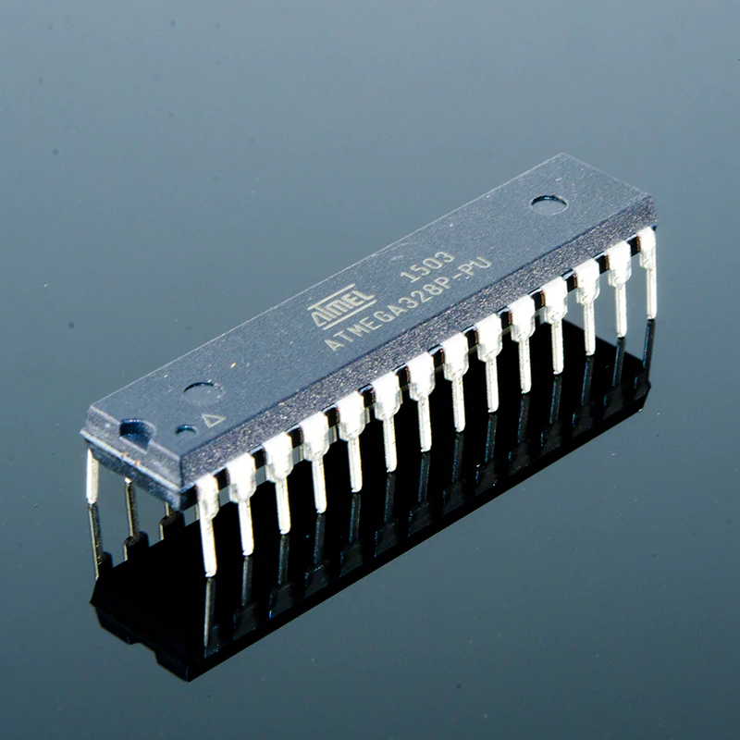

A microcontroller is a small and low-cost microcomputer, which is designed to perform the specific tasks of embedded systems like displaying microwave’s information, receiving remote signals, etc. The general microcontroller consists of the processor, the memory (RAM, ROM, EPROM), Serial ports, peripherals (timers, counters), etc.

Fig 2: Microcontroller

**Temperature sensor**

**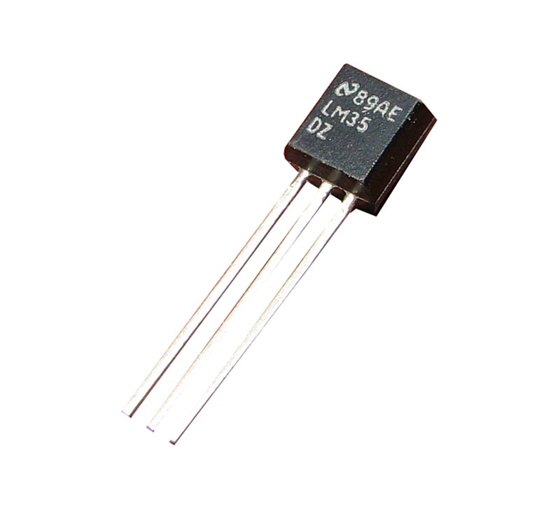**

Semiconductor Temperature Sensors “Semiconductor Temperature Sensor” is based on the fact that the junction voltage across a p-n combination of semiconductors, like a diode junction or “base-emitter” junction of regular transistors, is a function of temperature. This technology is vastly used in electronic devices and IC technologies.

**4 channel 5v relay module**

This is a 5 volt 4-channel relay interface board with a driving current of 15-20mA. It may be used to control a wide range of high current machinery & appliances. It is equipped with high current relays that may function at either AC250 volt 10A or DC30 volt 10A. It features a particular interface that may be controlled directly by a micro-controller.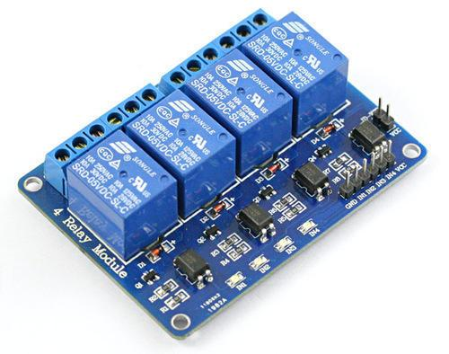

Fig 3: 4 Channel 5v relay module

**Gas sensor**

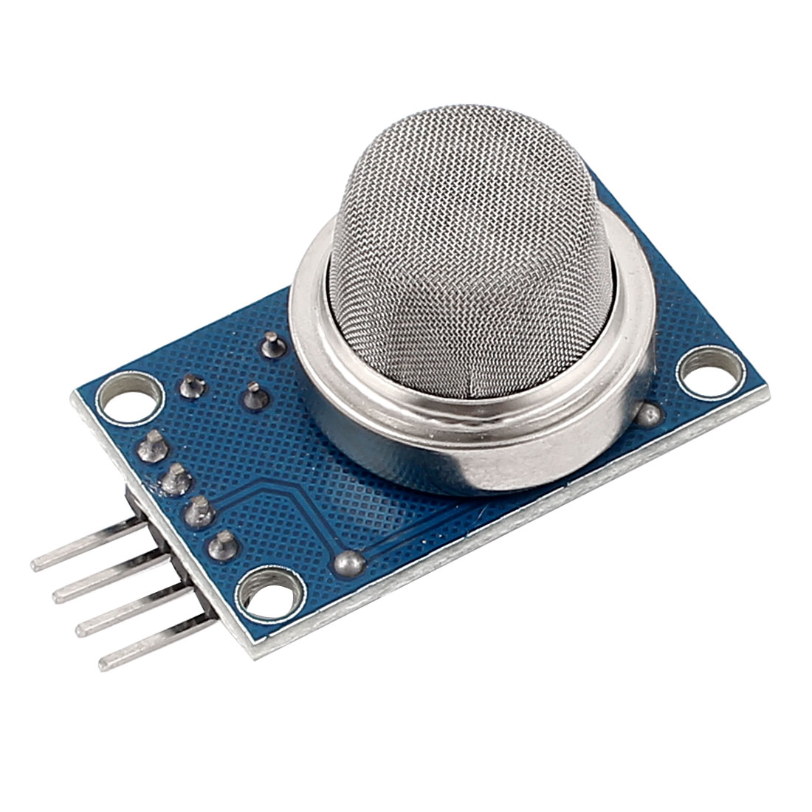

Gas sensor is an electronic sensor used for sensing the concentration of gases in the air such as LPG, propane, methane, hydrogen, alcohol, smoke and carbon monoxide.

**Pir sensor**

**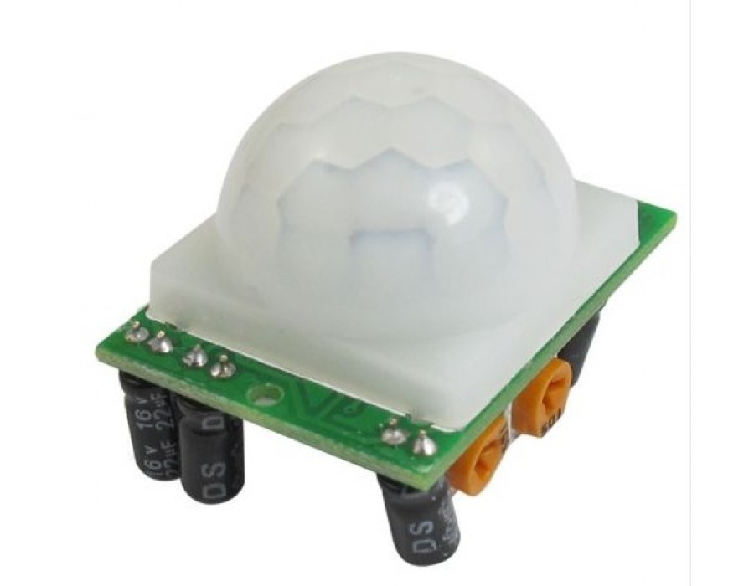**

A passive infrared sensor (PIR sensor) is an electronic sensor that measures infrared (IR) light radiating from objects in its field of view. They are most often used in PIR-based motion detectors. ... A PIR motion detector used to control an outdoor, automatic light.

**2 Relay module**

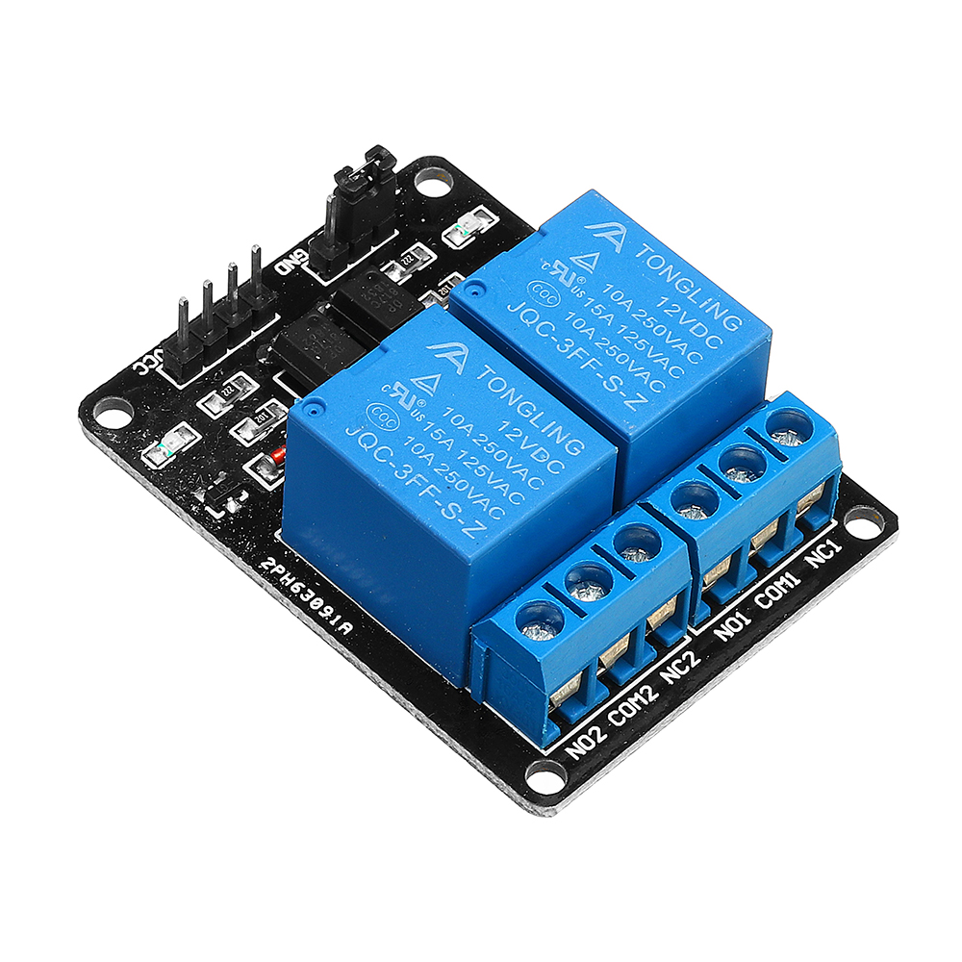

 Channel Relay Module with Optocoupler LOW Level Triger expansion board, which is compatible with arduino Standard interface that can be controlled directly by microcontroller ( 8051, AVR, \*PIC, DSP, ARM, ARM, MSP430, TTL logic) Relay of high quality loose music relays SPDT.

**3.5 Software Specifications:**

**Visual basic**

Visual Basic is a third-generation event-driven programming language first released by Microsoft in 1991. It evolved from the earlier DOS version called BASIC. BASIC means B eginners' A ll-purpose S ymbolic I nstruction C ode.

**Arduino**

The Arduino IDE is a cross-platform software develop-ed in C ++ and C functions. And is used to upload and build programme’s to Arduino compatible board’s and other development board’s with 3rd party core compatibility.

**3.6 Work Plan**

Month 1 – Literature Survey and Collecting hardware components.

Month 2 - Working on proto type.

Month 3 - Working on software application.

Month 4 - Testing the final model.

Month 5 - Working on paper and report.

**3.7 Realistic Constraints**

* Cost effective
* Wireless technology is used
* Portable to any place
* Efficient monitoring

**3.8 Multidisciplinary Tasks Involved**

| Other Department | Utilised for | Remarks |
| --- | --- | --- |
| Basic Sciences |  |  |
| Mechanical/Mechatronics/Auto mobile/Aero-nautical/Civil Engineering, etc |  |  |
| Instrumentation and Control Engineering |  |  |
| Electrical and Electronics Engineering | Arduino |  |
| Biomedical /Biotech Engineering |  |  |
| Computational/IT | Visual basic |  |
| Business/Management |  |  |
| Purchase Section |  |  |
| Maintenance Department |  |  |
| Desktop publications | Report |  |

Table 2: Multidisciplinary Tasks Involved

**CHAPTER 4**

**WORKING**

**4.1 Proposed Design**

**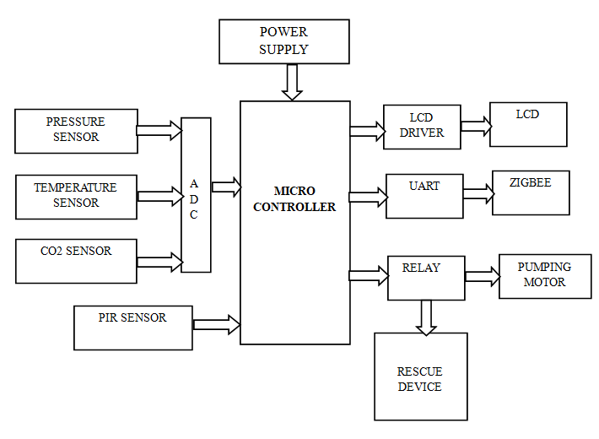**

Fig 8: Proposed Design

**4.2 Prototype**

**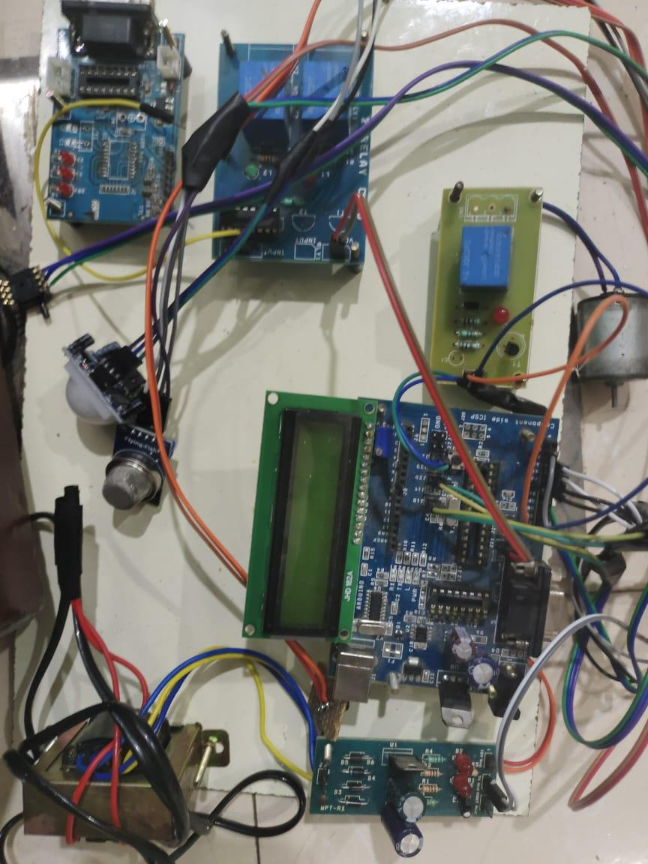**

Fig 9: Prototype

**4.3 Result**

Software used for the project

**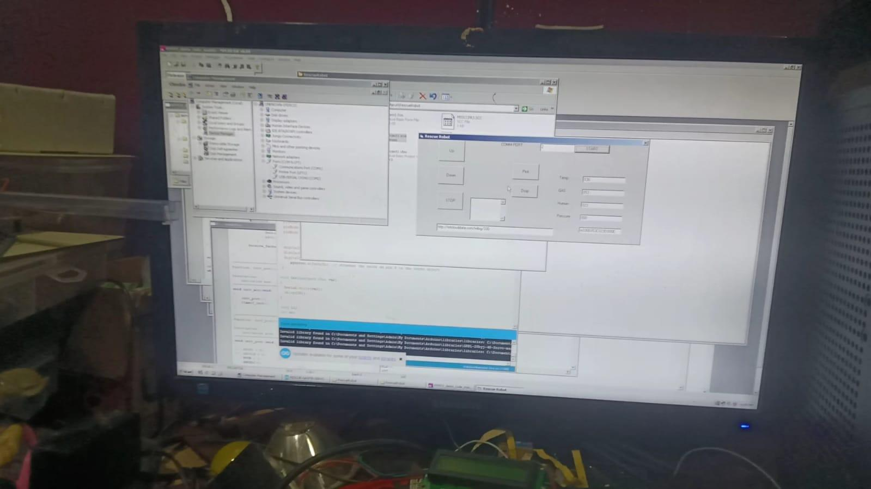**

**Fig 10 visual basic**

**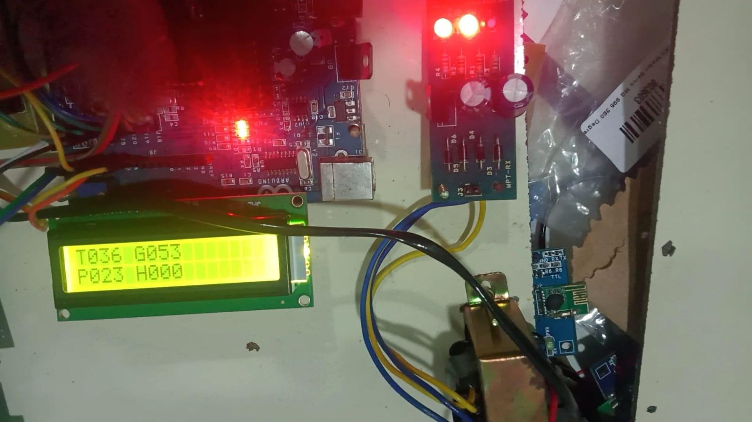**

**Fig 11 sensor values and output**

**4.4 Applications :**

* Toddler rescuing from borewell.
* Man hole rescue.
* Train tunnel accidents rescuing.
* Coal tunnel accidents rescuing.

**4.5 Budget :**

| **Component name** | **Price in Rupees** |
| --- | --- |
| Micro controller | 300 |
| 4 way Relay module | 220 |
| Lcd | 200 |
| zigbee | 2500 |
| gas sensor | 750 |
| **Total =** | 3970 |

Table 3 : Budget

**CHAPTER 5**

**CONCLUSION**

Human life is precious. Our bore well child recue system is a significant attempt to save the life of the victim of bore well accidents. Besides this, the unique capability of climbing through vertical and inclined pipes makes wide scope of application for this machine in manufacturing industries and other relevant fields. In the current design of bore well child saver machine has been made to suit every possible situation may occur in rescuing operation. Further, we would like to conclude that with the help of our project, we would be able to rescue the child safely within short period of time.

**CHAPTER 6**

**FUTURE WORK**

* It can be used for human from borewells.
* To save a baby from depth borewells.

**References**

[1] G Kavianand ; K Gowri Ganesh ; P Karthikeyan, Smart child rescue system from borewell (SCRS), Published in: Emerging Trends in Engineering, Technology and Science (ICETETS), International Conference on , 24-26 Feb. 2016,IEEE Xplore: 24 October 2016

[2] B. Bharathi, B. Suchitha Samuel, "Design and Construction of Rescue Robot and Pipeline Inspection Using Zigbee", International Journal Of Scientific Engineering and Research (IJSER), vol. 1, no. 1, September 2013K. Elissa, “Title of paper if known,” unpublished.

[3] Palwinder kaur, Ravinder kaur, Gurpreet singh, "Pipeline Inspection And Bore well Rescue Robot", International Journal of Research in Engineering and Technology(IJRET), vol. 03, no. 04, April 2014.

[4] Raj Manish, P. Chakraborty, G.C. Nandi, "Rescue robotics in bore well Environment", Cornell university library [v1] Mon, Jun 2014.

[5] John Jose pottery, "robot for bore well rescue", amal jothi college of engineering, vol. 10, Jun 2009.

[6] S. Gopinath, T. Devika, L. Manivannan, N. Suthanthira Vanitha, "Rescue Child from Bore well using Embedded System", 2015.

[7] V. Venmathi, E. Poorniya, S. Sumathi, "Borewell Rescue Robot", International Journal of Computer Applications, vol. 113, no. 14, 2015.

[8] C.N. Sakhale, 2D.M. Mate, 3Subhasis Saha, Tomar Dharmpal, Pranjit Kar, Arindam Sarkar, Rupam Choudhury, Shahil Kumar, "An Approach to Design of Child Saver Machine for Child Trapped in Borehole", International Journal of Research in Mechanical Engineering, pp. 26-38, October-December 2013.

[9] G. Nithin, G. Gowtham, G. Venkatachalam, S. Narayanan, "School of Mechanical Building Sciences" in Design and Simulation of Bore well rescue robot- Advanced ARPN Journal of Engineering and Applied Sciences, India:VIT University, MAY 2014.

[10] Sridhar Palaniswamy, "Life Saving Machine", first International Conference on Interdisciplinary Research and Development, 31 May-1 June 2011. [11] C. Kemp, A. Edsinger 2007, Challenges for Robot Manipulation in Human Environments. IEEE Robotics & Automation Magazine, 2007 pp. 2029

[11] Kurukuti, Nish Mohit, Et A1. "A Novel Design of Robotic System for Rescue in Bore Well Accidents." 2016 International Conference on Robotics and Automation for Humanitarian Applications (Raha). IEEE, 2016.

[12] Sridhar, K.P., and C. R. Hema. “Design and Analysis of a Bore well Gripper System for Rescue." Arpn Journal of Engineering and Applied Sciences 10.9 (2015):4029-4035.

[13] V Venmathi, E Poorniya, S Sumathi,” Borewell Rescue Robot, International Journal of Computer Applications, 1(3), 2015, 14-23.

[14] K Saran, S Vignesh, Marlon Jones Louis, “Bore-well Rescue Robot”, International Journal of Research Aeronautical and Mechanical Engineering, 1(4), 2014, 61-80

[15] Gopinath, S., T. Devika, L. Manivannan and N. Suthanthira Vanitha "Rescue Child from bore well using Embedded System.”

[16] Pal winder Kaur, Ravinder Kaur, Gurpreet Singh, “Pipeline Inspection and Bore Well Rescue Robot”, International Journal of Research in Engineering and Technology, 2(5), 2014, 04-12

. [17] S. K, V. S and M. J. Louis, "Bore Well Rescue Robot, " International Journal of Research In Aeronautical And Mechanical Engineering, vol. 2, no. 4,pp.6180,, April, 2014.

[18] B Bharath, B Ruchitha Samuel, “Design and construction of rescue robot and pipeline Inspection using ZigBee”, International Journal of Scientific Engineering and Research, 1(2), 2013, 42-4

.

**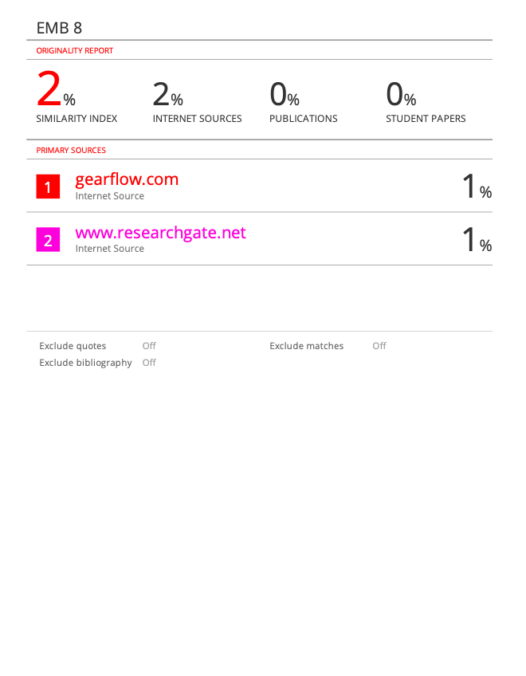**

IMG_256

**SRM INSTITUTE OF SCIENCE AND TECHNOLOGY**

**College of Engineering and Technology**

**Department of Electronics and Communication Engineering**

18ECP109L- PROJECT

**ACADEMIC YEAR: 2021-22**

PROJECT SUMMARY REPORT

| **Project Title :I**mplementation of child rescue system from borewell from using zigbee for long range applications  **Project Domain :** 18ECP109L/ Communication  **Project Members :** Yarabolu Sisindhar Reddy(RA1811004010644)  Gudipati Siva manas (RA1811004010645)  M.rakesh (RA1811004010649)  **Name of the Guide & Designation :** Dr. R.Manohari (Assistant Professor) |
| --- |

| **Related Course studied in last semesters:**  18ECC205J - Analog and digital communication |
| --- |

| **Objective:**  1.Manually monitoring the child with the help of an controlling unit of system. 2. Communicating with the system by sending appropriate commands to it and activate the suitable motors.  3. Once the system has reached proximity of child, it is stopped immediately and is given the commands by the controlling device to perform the closing of the systemic arms. 4. Controlling a system to takeoff the child inside the bore well, which is controlled by the person from outside. |
| --- |

| **Technical Requirements (both Hardware & Software):**  Hardware : micro controller ,4 way Relay module, pir sensor,temperature sensor,lcd,zigbee,gas sensor,pressure sensor.  Software :Visual Basic, Arduino, |
| --- |

| **Work Scheduled Plan (Month wise):**  Month 1 – Literature Survey and Collecting hardware components.  Month 2 - Working on proto type.  Month 3 - Working on software application.  Month 4 - Testing the final model.  Month 5 - Working on paper and report. |
| --- |

| **Engineering Standards Referred/Used:**   | **Area** | **Codes & Standards / Realistic Constraints** | | --- | --- | | Economic | Targeted to maximum expense of Rs 4000/-. | | Environmental | This project is not expected to entail any particular environmental consequences. | | Social | This project aims for surveillance and security, hence for the .Welfare of the society. | | Ethical | This project is not expected to entail ethical constraints. | | Health and Safety | This project is not expected to entail health and safety constraints. | | Manufacturability | This project must be easily replicated. This requires *complete* schematics, *complete and documented* code listings, bill of materials, and C produced in a file format accessible by software available at Simulation Lab. | | Sustainability | The resources used in this project (micro controller ,4 way Relay,pir sensor,temperature sensor,gas sensor,pressure sensor,zigbee.). | |
| --- | --- | --- | --- | --- | --- | --- | --- | --- | --- | --- | --- | --- | --- | --- | --- | --- |

| **Realistic Constraints(with quantitative data):**   * To rescue the baby. * The new zigbee wireless technology is used. |
| --- |

| **Area** | **Possible Constraints** |
| --- | --- |
| Accessibility | - |
| Codes & Constructability | - |
| Functionality and interoperability | - |
| Economic | Targeted to maximum expense of Rs 1500/- |
| Environmental | This project is not expected to entail any particular environmental consequences. |
| Social | This project aims for surveillance and security, hence for the .Welfare of the society. |
| Ethical | This project is not expected to entail ethical constraints. |
| Health and Safety | This project is not expected to entail health and safety constraints. |
| Legal Considerations | - |
| Manufacturability & Marketability | This project must be easily replicated. This requires *complete* schematics, *complete and documented* code listings, bill of materials, and C produced in a file format accessible by software available at Simulation Lab. |
| Policy, Standards and regulations | - |
| Schedule | The project has been completed within a time period of 90 Days. |
| Sustainability (Usability) | The resources used in this project (Esp32,4v way relay module, bulbs, socket, bulb holders, breadboard, power supply, android mobile). |

**Multidisciplinary Tasks Involved**

| Other Department | Utilised for | Remarks |
| --- | --- | --- |
| Basic Sciences |  |  |
| Mechanical/Mechatronics/Auto mobile/Aero-nautical/Civil Engineering, etc |  |  |
| Instrumentation and Control Engineering |  |  |
| Electrical and Electronics Engineering | Arduino |  |
| Biomedical /Biotech Engineering |  |  |
| Computational/IT |  |  |
| Business/Management |  |  |
| Purchase Section |  |  |
| Maintenance Department |  |  |
| Desktop publications | Report |  |

| **Deliverables/Outcomes:**  1.A prototype will be constructed.  2.Interfacing blynk in unity software to create an mobile application.  3.Controlling the appliances by virtual buttons using the mobile application. |
| --- |

| **Publication Details: (includes publication in conference/ journal/patent):**  - |
| --- |
| **Budget (Includes Hardware, Software, Miscellaneous, etc.):**  ESP32 625  4 way Relay module 220  Bulbs 300  Bulb Holder & Socket 200  Breadboard 150  Total                                                   =1500 |

| **Future Scope:**  1.Can be implemented in OS like IOS.  2.Can be implemented in AR glasses. |
| --- |